Stefano Signorelli

**Final Design Package:**

The chosen design must be fully detailed. The interactions between all parts should be discussed. Instructions for using the system and/or product must also be given (in report format). The method in which the parts are produced and assembled should also be given. The software system, if applicable, should be fully described so that any future design effort can quickly understand the software design approach. A complete set of part and assembly drawings is essential, as is a complete bill of materials. For any commercial off the shelf (COTS) parts in your design, vendors and part numbers should be included.

------------------------------------------------------------------------------------------------------------------------------

Add:

How to compile parts

Detailed drawings and Instructions for HoloLens [Amy]

Bill of materials, costs.

**Bill of materials:**

* Microsoft Hololens (1st gen) ($810 new on Ebay plus $30 for shipping)
* WiFi 6 Netgear AX1800 Wireless Access Point ($40 new on Amazon)
* Playing Card with Chips ($7 new on Amazon)
* Total price for needed items is $887
* Total budget is $1000 to cover tax when purchasing.

Note:

The final design as of now does not have the full Microsoft Hololens implementation working, but it is listed here because it was intended to be a part of the final project solution.

**Compilation of GameLogic.cs and Launch:**

The compilation of code in the Unity project is done automatically if changes are made to the file. The only change that would be performed is if a new computer is being used, and the path to the blackjack.py file needs to be specified in the “GameLogic.cs” C# script. If not doing this change, there is no need to compile anything, it should be ready to launch when pressing the start/stop button on the Unity Editor after opening the project folder through “Unity Hub”. When the game runs, it will launch the Python script continuously. No compilation needs to be done for Python since it was compiled once to get it functioning.

**Compilation of YOLO related files and Launch:**

UML Diagrams

Unity Project: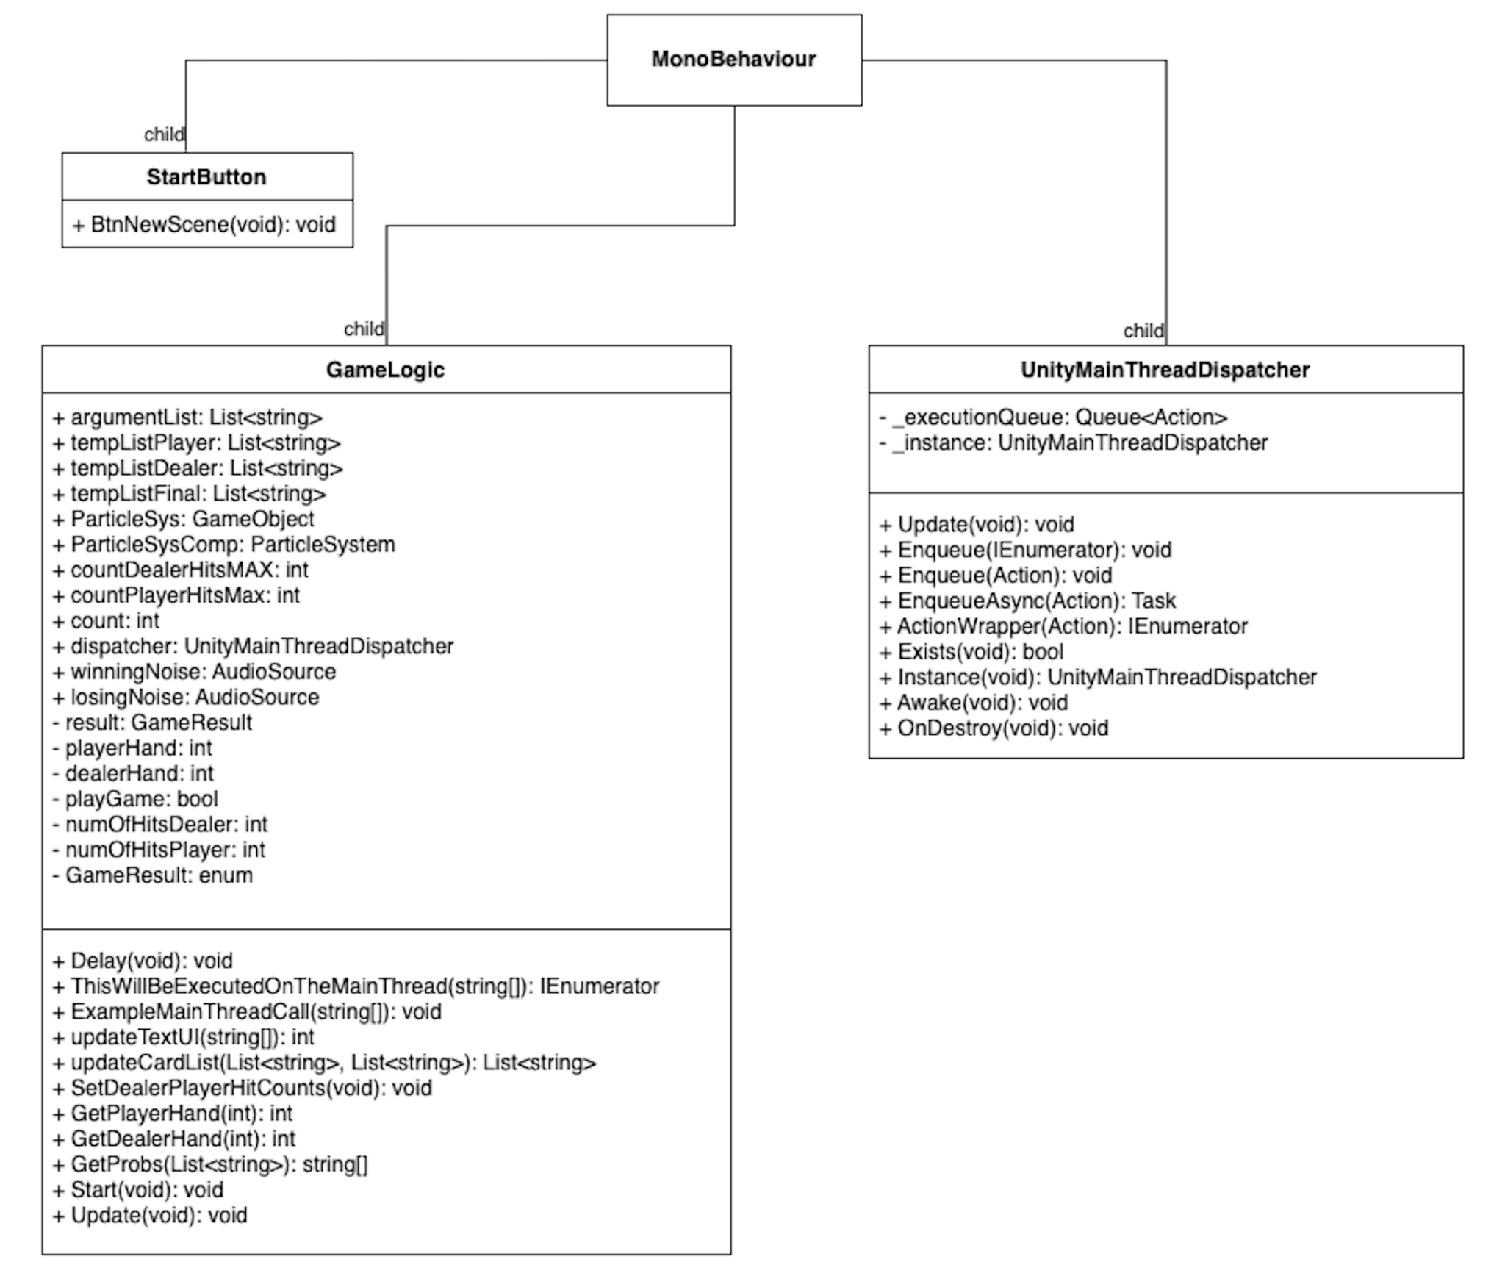

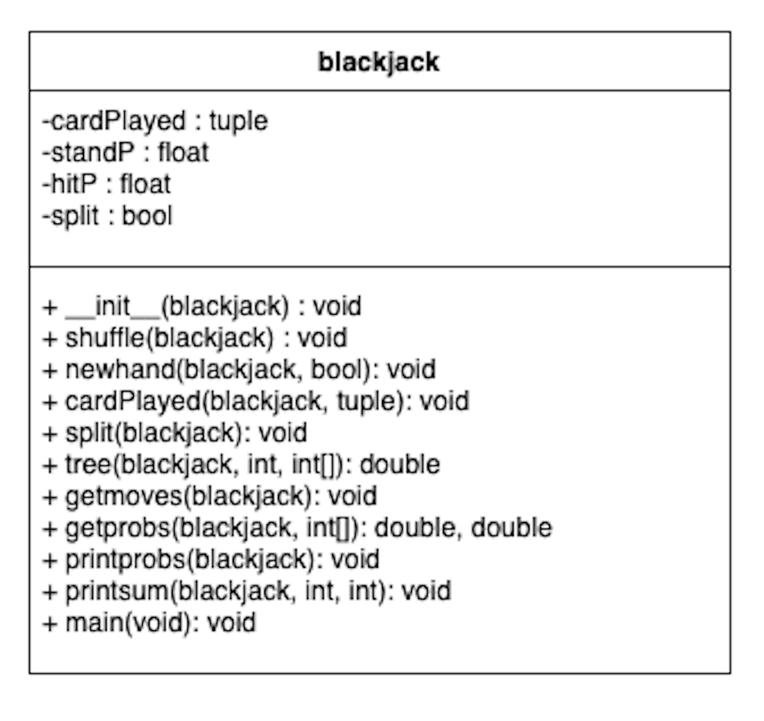

Object Detection:

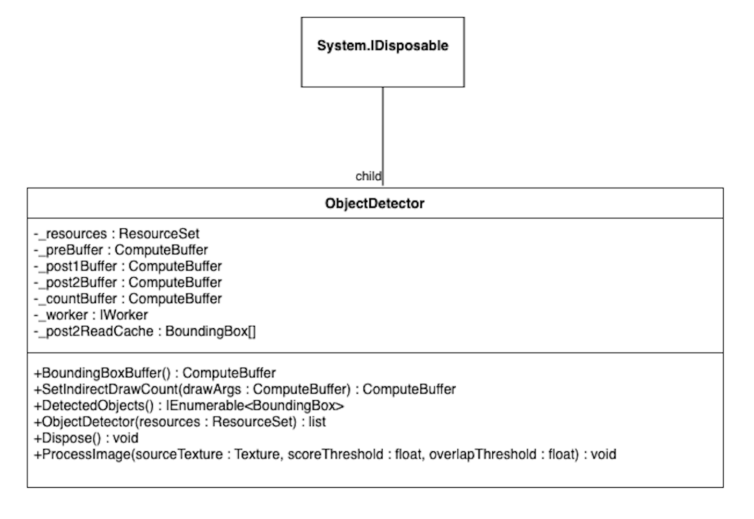

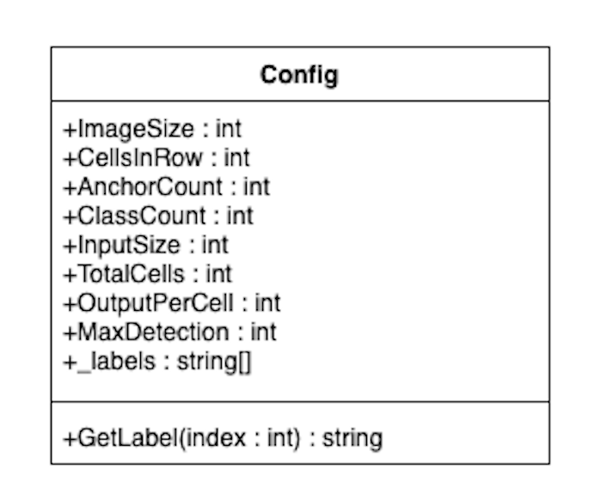

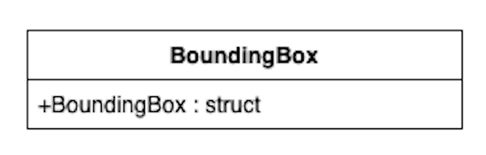

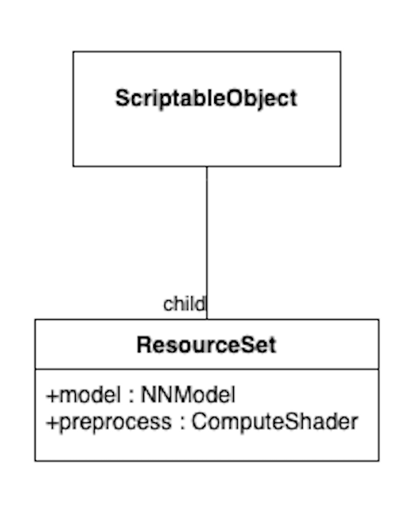

User manual and instructions

User manuals should be given for the design. These manuals should be appropriate for use by either the sponsor or the end user (if the design is a product marketed by the sponsor). These should be given in the form of a step-by-step guide to using the product. A troubleshooting and common-problems section can also be included if necessary.

---------------------------------------------------------------------------------------------------------------------

Note: having screen shots of the actual tasks for launching etc would be nice. This was hypothetical.

User Manual and Instructions

By, Amyleila Mejia

# Table of Contents

**Table of Contents** **1**

**Introduction** **2**

**Maintenance Instructions** **2**

**Parts and Materials** **2**

Hololens Gen 1 Components 3

**User Manual & Instructions** **3**

**1.)Turn ON** **3**

Table 1: Hololens proper adjustment methods and handling. 4

Figure 2: Power device overview. Charging and button locations can be clearly seen. 5

**2.) Brightness and Volume Adjustment** **5**

Figure 4: Power 6

**3.) Unity Game Engine Project Selection** **6**

Figure 5: Unity Game Engine list of projects to select from. 6

Figure 6: Unity Game Engine Project opened view. 7

**4.) Unity Game ENgine Build Settings** **8**

Figure 7: Unity Game Engine Project view using file drop down menu to build game settings. 8

**5.) Universal Windows Platform Configuration Settings Using Unity Game Engine** **8**

Table 2: Universal Windows Platform configuration settings. 9

Figure 8: Unity game engine project build settings view. 10

**6.) Using the Hololens Emulator for App Launch** **10**

**7.) Using the App** **10**

Figure 9: Hololens Emulator view of app launch. 10

**8.) System Shutdown** **11**

**Appendix** **12**

# Introduction

Dr. Omid Semiari requested that an improvement be made to the hardware and software performance of the Hololens Gen 1 by using a host computer to process the applications and render everything to the Hololens. His idea was that the host computer could improve the performance and battery life of the Hololens. Improvement to the hololens times could be improved by XAMOUNT. This analysis will be done in the testing phase for a comparison on the normal operations of the Hololens without a host computer and then with the addition of the host computer to see if any improvements were made. This project will most likely be passed on to another class to see what other improvements can be made.

# Maintenance Instructions

For troubleshooting the Hololens the Microsoft Ignite Documentation Online is a great source to reference they are up to date on the issues any owner of a Hololens has faced and detailed documentation on what to do in these situations is available. The link is: [HoloLens (1st gen) hardware | Microsoft Learn](https://learn.microsoft.com/en-us/hololens/hololens1-hardware). This site is useful because it also has a variety of information for users to include user instructions for first time users of a Hololens. They also provide links to online communities that use the Hololens to render applications that can be of use to the user.

# Parts and Materials

1. Hololens Gen 1

### Hololens Gen 1 Components

1. Router
2. Cables used for Router
3. Host Computer
4. 2 Handheld Remotes

# User Manual & Instructions

# 1.)Turn ON

***Figure 1:*** Desktop version of the Unity Game Engine Launcher.

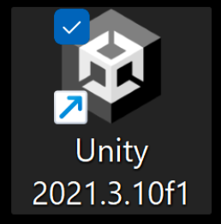

1. To turn on the HoloLens Gen 1 there is a button at the back of the hololens, figure 2, the button must be held down for four seconds.
2. Turning on the device also requires turning on the app for full interaction.
3. Open the project file in the host computer. The icon the user will need to find on the host computer desktop can be referenced in figure 1.
4. The user will enable and launch the app, figure 1, by interacting with the Unity Game Engine and double clicking on the app icon.

### Table 1: Hololens proper adjustment methods and handling.

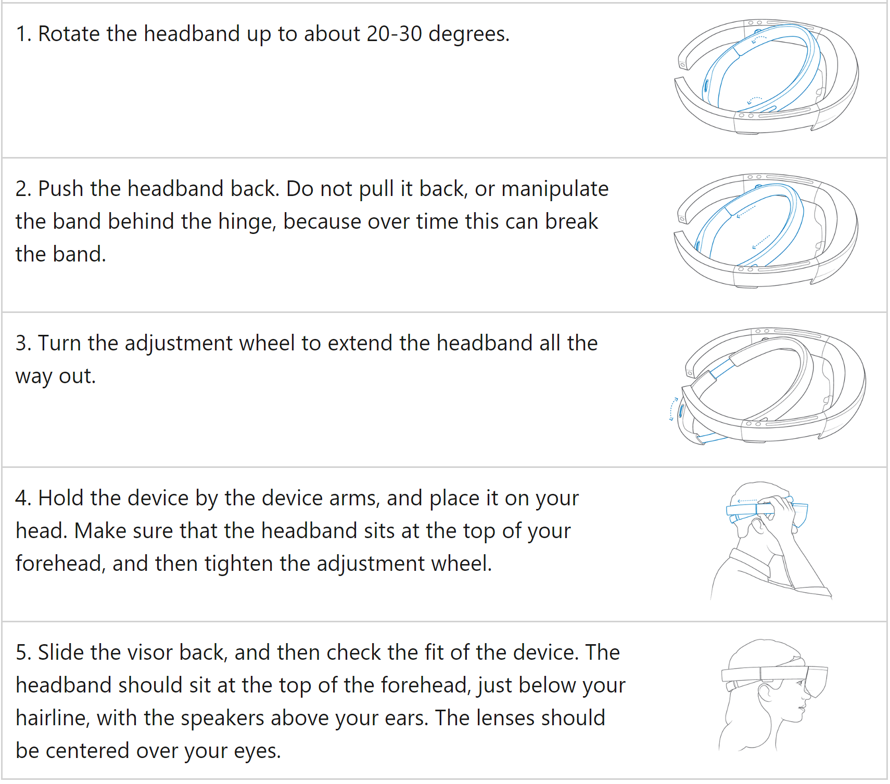

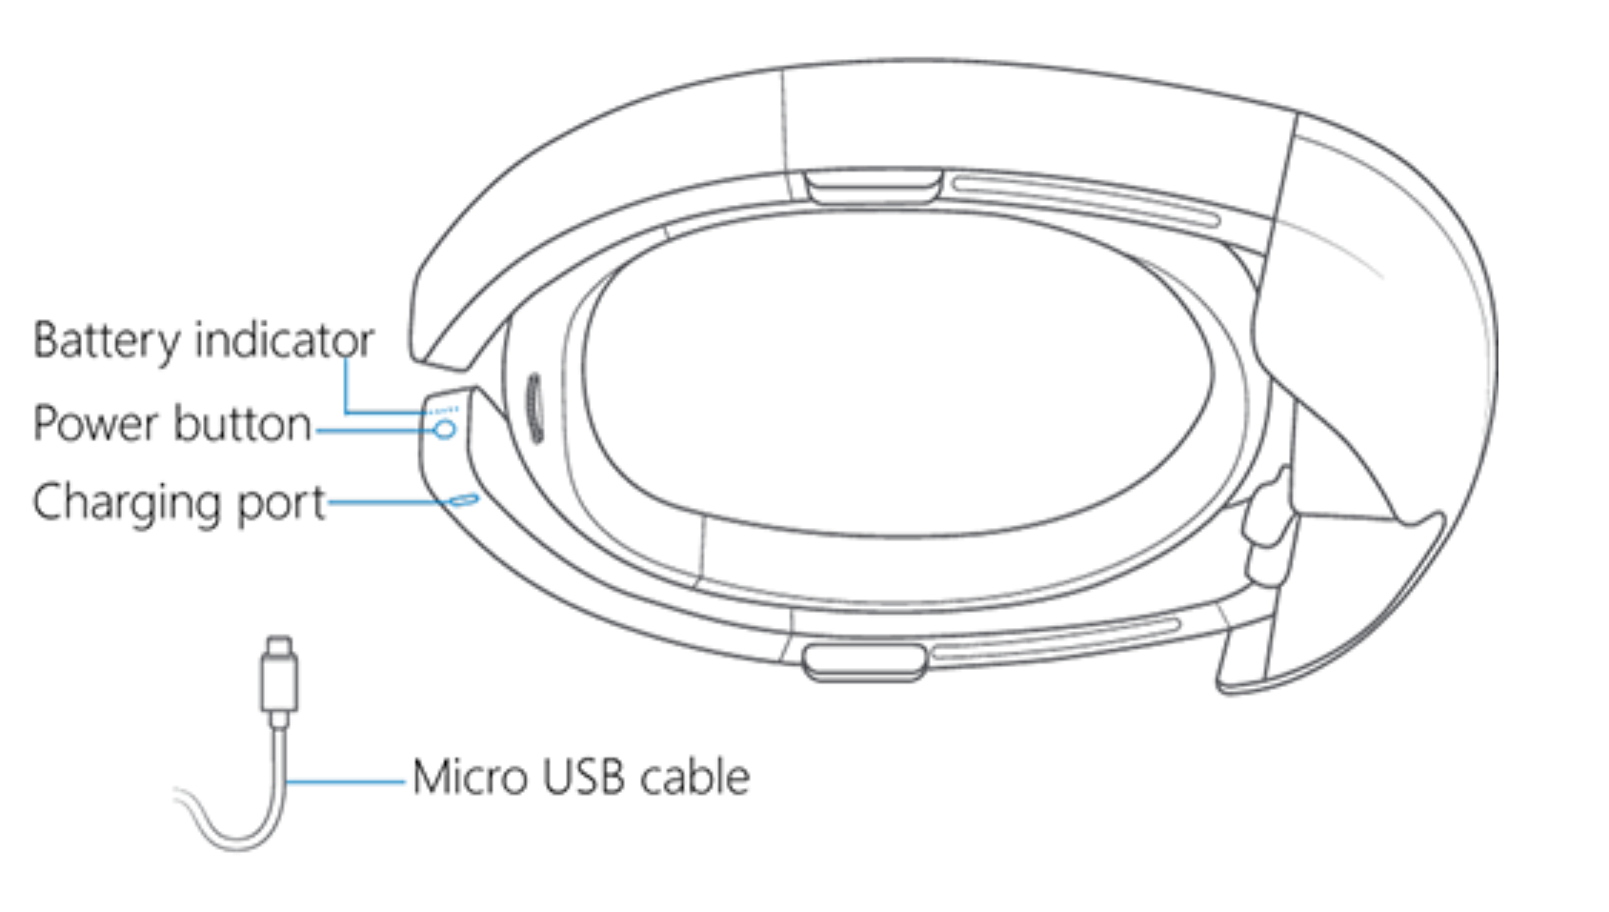

### ***Figure 2:*** Power device overview. Charging and button locations can be clearly seen.

# 2.) Brightness and Volume Adjustment

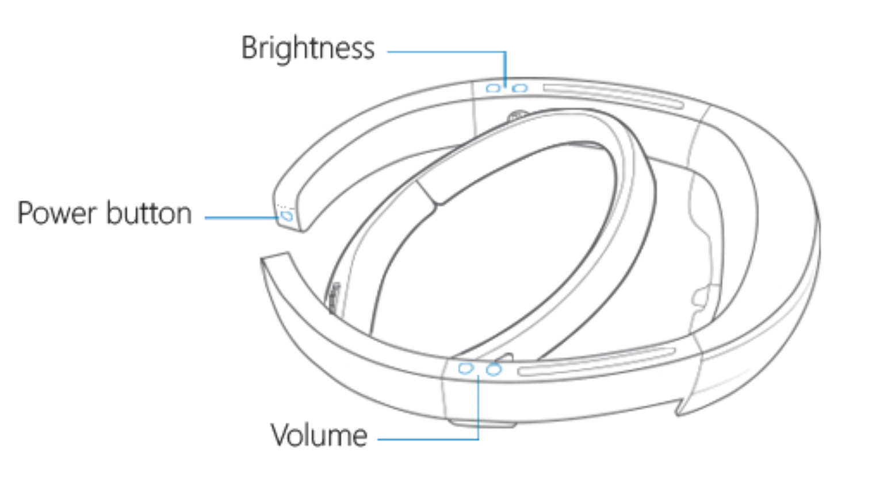

Table 1 demonstrates the steps that are necessary for the adjustment process to take place.

1. Rotate the inner headband to about 30 degrees.
2. Put the headband on to secure Hololens on your head.
3. There is an adjustment wheel located in the back of the inner headband that can be turned to adjust the headband to the circumference of the head.
4. Make sure to adjust the tightness that supports the Hololens and is not loose otherwise there could be injury in to the person or damage to the device

### ***Figure 4:*** Power

# 3.) Unity Game Engine Project Selection

1. Once the user double clicks the app icon the project drop down menu will be opened in the Unity Game Engine and can be referenced in figure 5.
2. The user will then proceed to go to the drop down menu under the projects file, figure 5, and find the corresponding project to select. This will open up that project. The example from figure 5 is the folder my_first_unity.

### ***Figure 5:*** Unity Game Engine list of projects to select from.

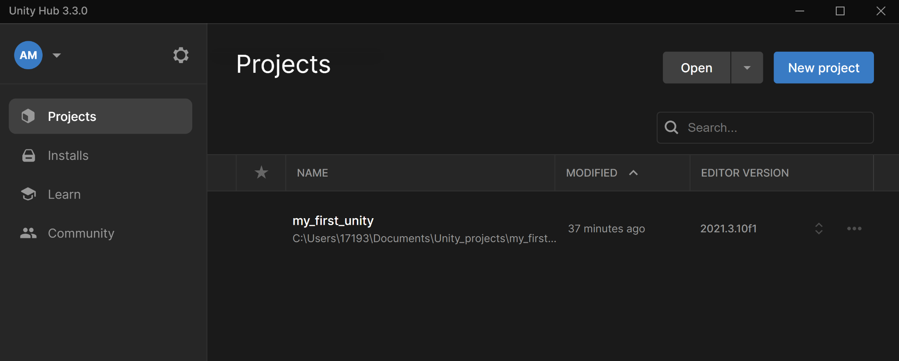

# 4.) Unity Game ENgine Build Settings

### ***Figure 6:*** Unity Game Engine Project opened view.

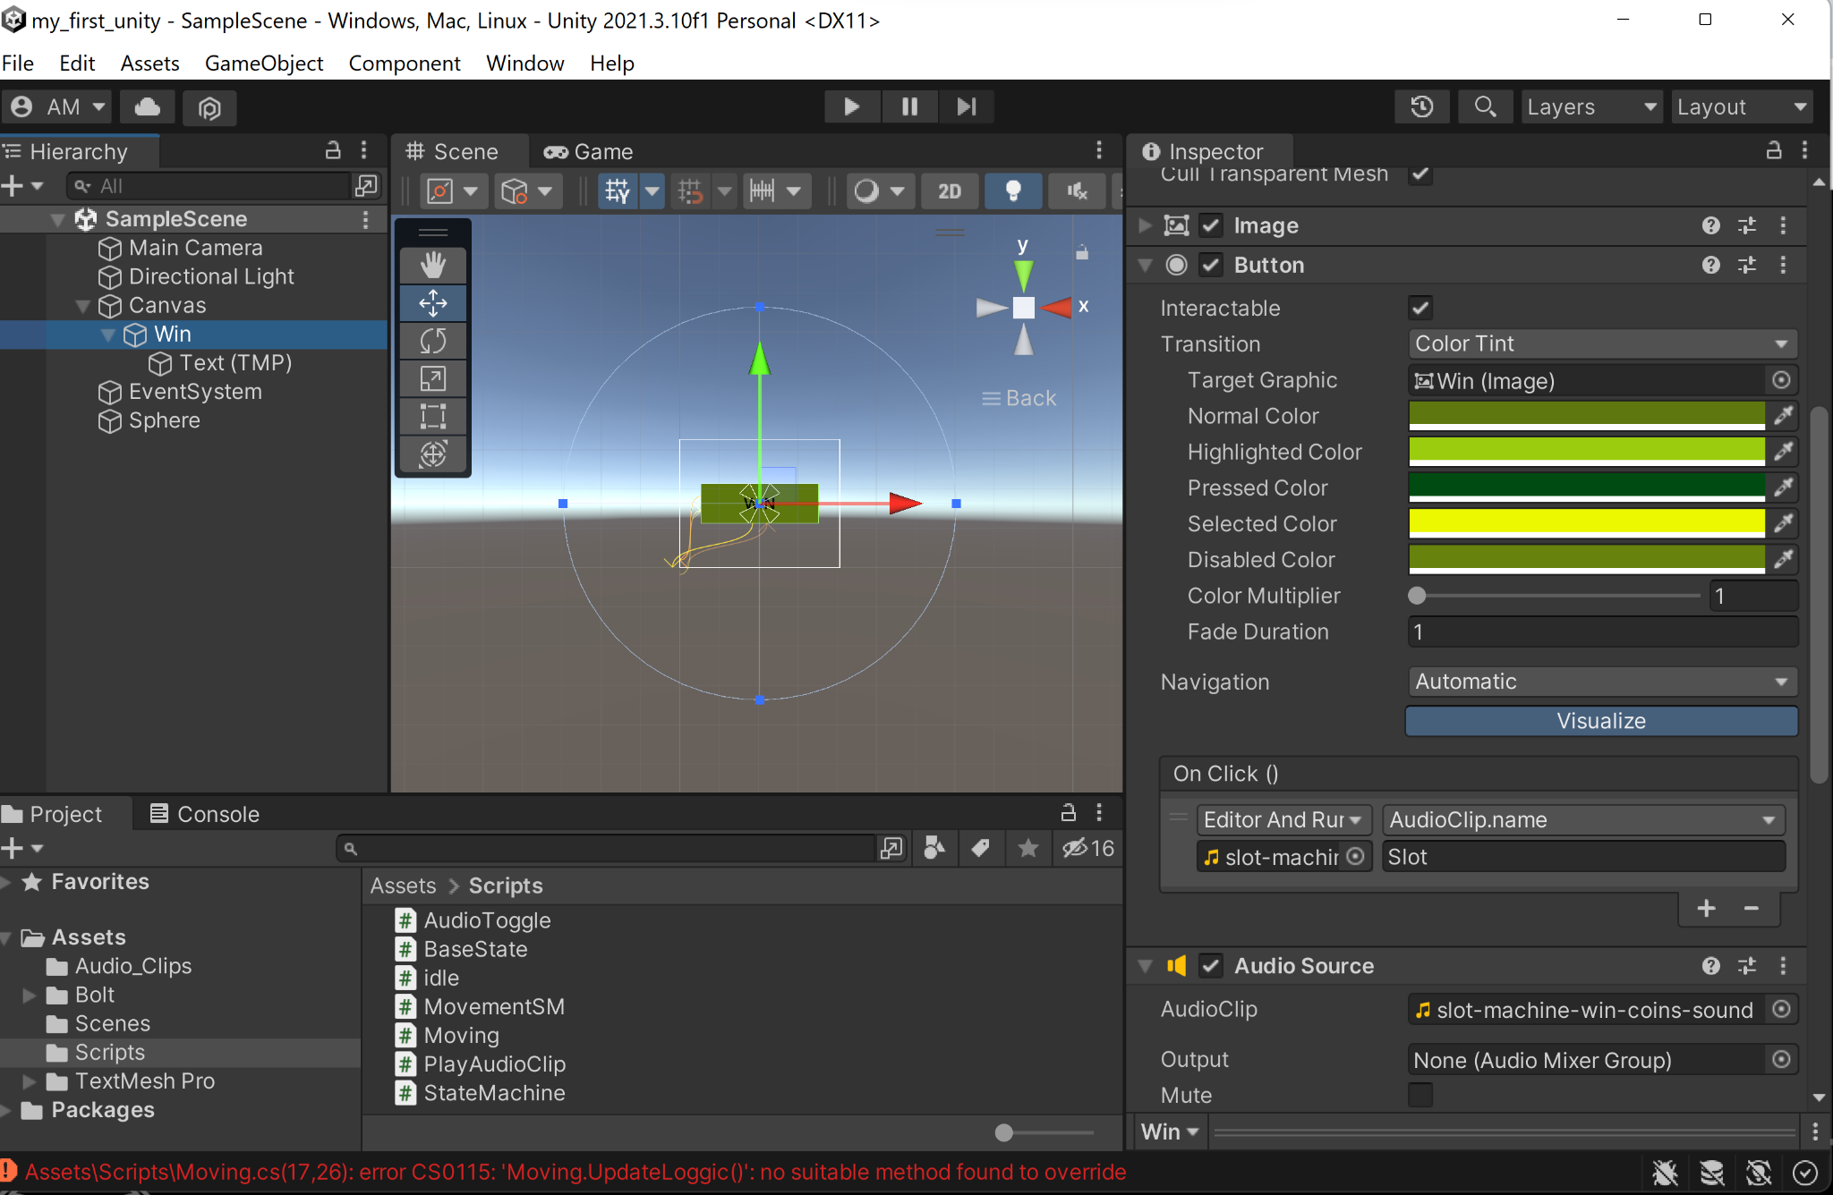

# 

### ***Figure 7:*** Unity Game Engine Project view using file drop down menu to build game settings.

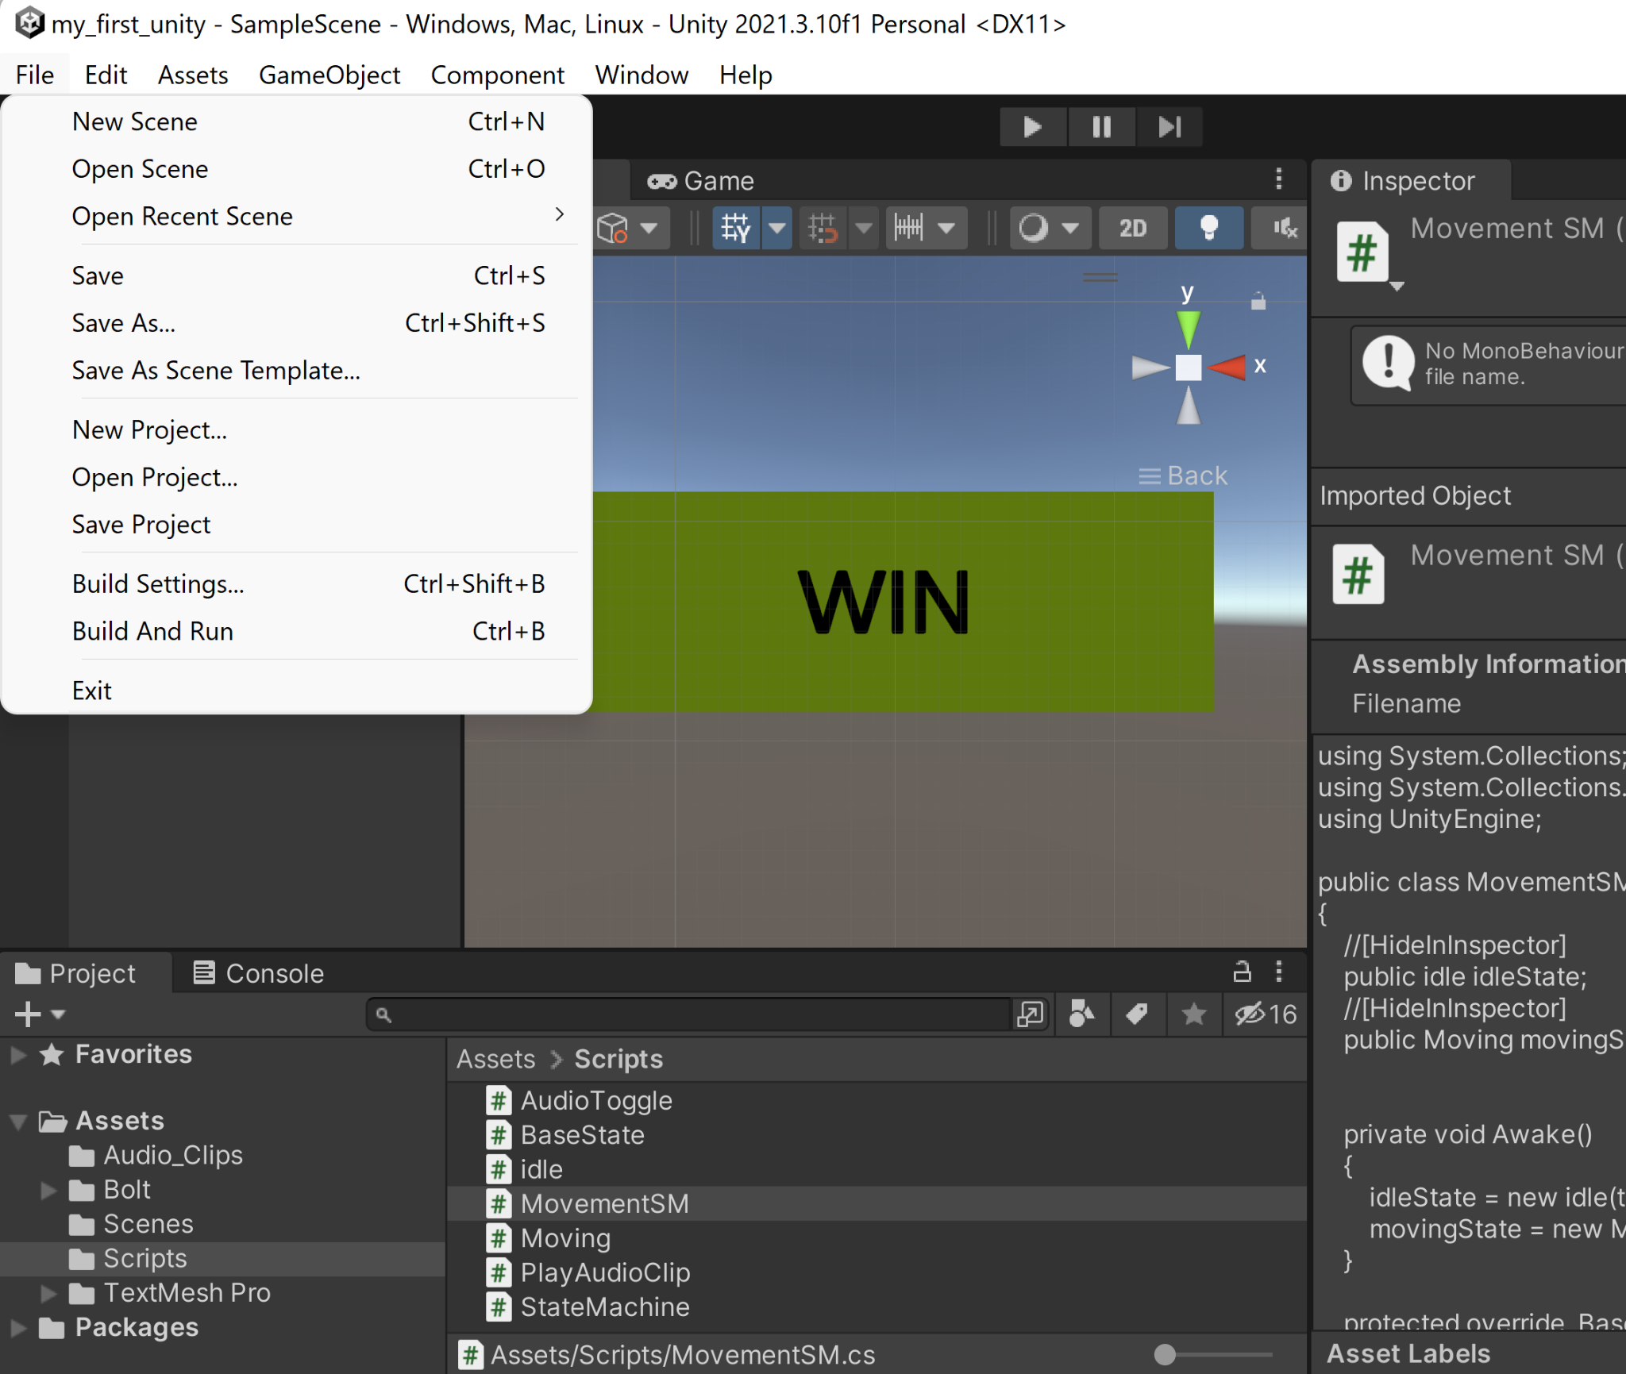

1. When the user successfully opens up the project file following figure 5 the window the user will see if using the Unity 2021.3.10f1 version will look like figure 6.
2. The user will need to configure the game settings in the unity game engine by selecting the file drop down menu and selecting build settings. This view can be found in figure 7.

# 5.) Universal Windows Platform Configuration Settings Using Unity Game Engine

The build settings will provide access to the Universal Windows Platform settings, figure 8. In order to successfully launch the project onto the Hololens the user will need to configure the Universal Windows Platform settings to properly render the game.

1. The first step in this process is to select the proper platform in use which in this case must be the Universal Windows Platform.
2. The user must first make sure to select the “Add Open Scenes”, this will automatically select the current project scene that is open and enable the platform configuration settings for that particular Scene/Project.
3. The platform settings must include the following configuration which can be referenced in table 2 and figure 8.
4. Once these settings have been configured the user must press build and run.

### Table 2: Universal Windows Platform configuration settings.

| Universal Windows Platform | Settings |
| --- | --- |
| Target Device | Hololens |
| Architecture | x64 |
| Build Type | D3D Project |
| Target SDK Version | Latest Installed |
| Minimum Platform Version | 10.0.10240.0 |
| Visual Studio Version | Latest Installed |
| Build and Run on | Local Machine |
| Build Configuration | Release |
| Copy References | Unselected |
| Copy PDB Files | Unselected |
| Development Build | Unselected |
| Autoconnect Profiler | Unselected |
| Script Debugging | Unselected |
| Scripts Only Build | Unselected |
| Compression Method | Default |

### ***Figure 8:*** Unity game engine project build settings view.

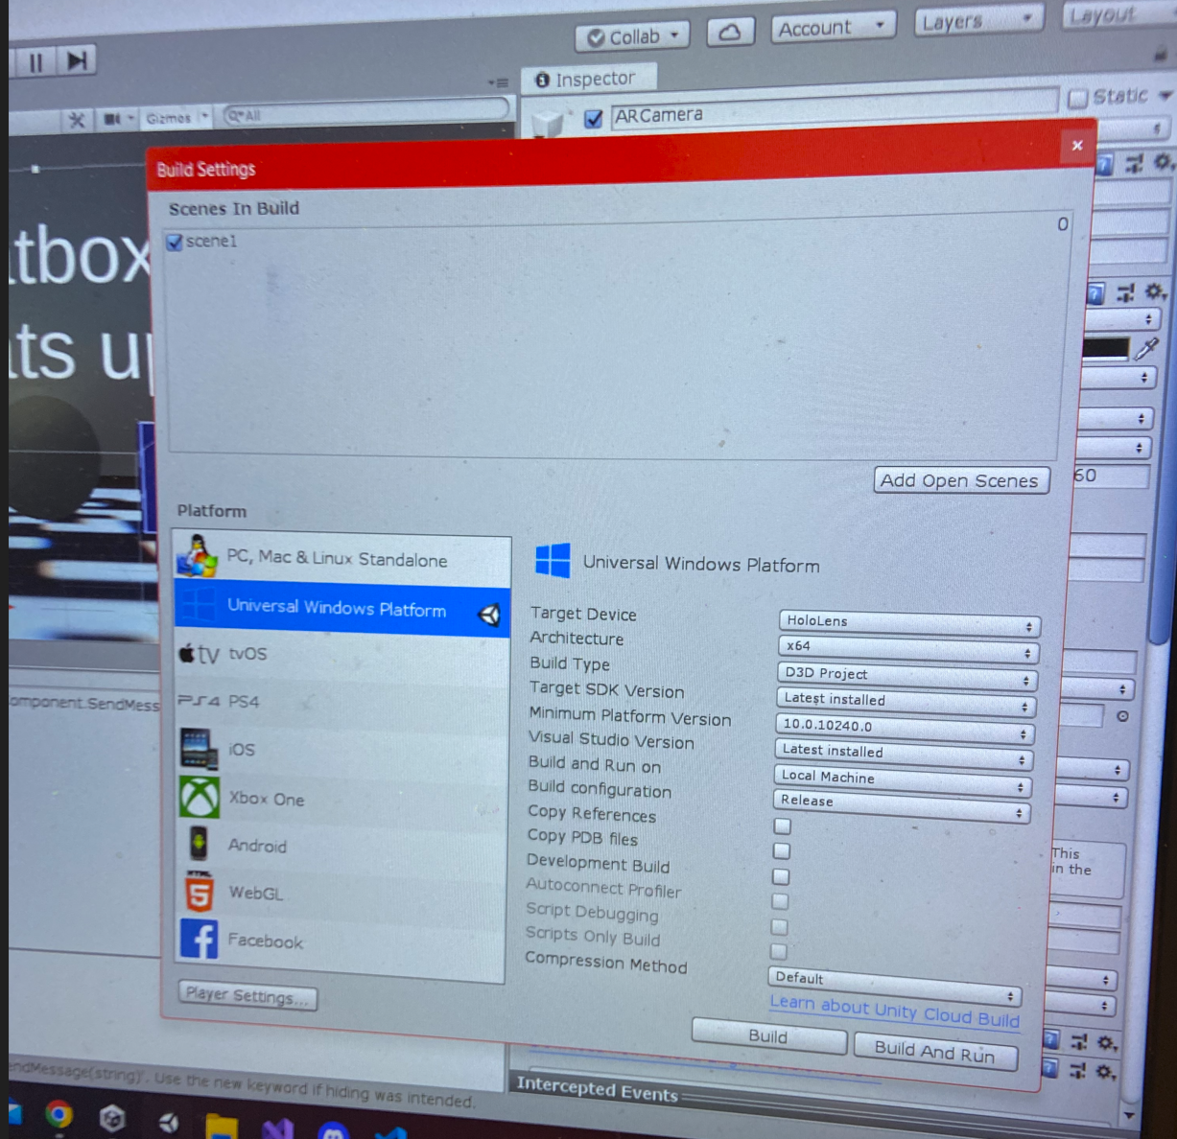

# 6.) Using the Hololens Emulator for App Launch

If the user decides to use the Hololens Emulator the configuration can vary slightly.

1. First the solution configuration setting must be changed from debug to master found on the upper left corner. That gives the user the option to run the project on the device, the Hololens.
2. Make sure to have the Hololens powered on and situated on head when pressing the start button on the Hololens Emulator because the start will automatically launch the app on the Hololens.

# 7.) Using the App

### ***Figure 9:*** Hololens Emulator view of app launch.

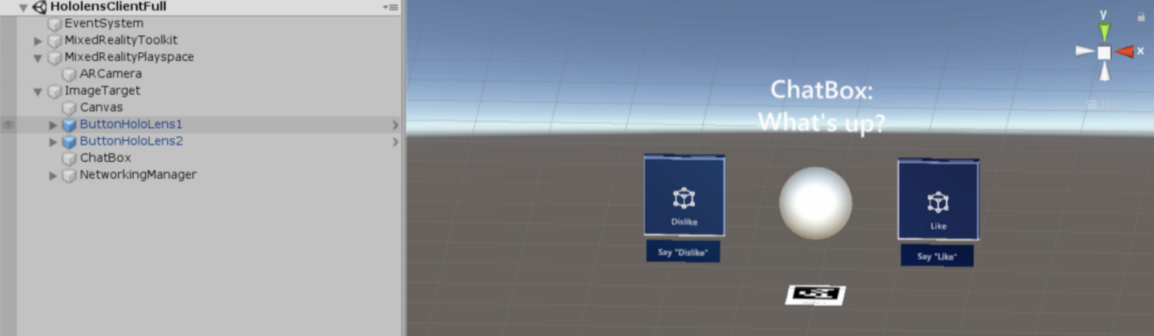

1. Click on the App icon using hand held remotes.

Once the app launches, the HoloLens comes with a pair of hand held remotes one for each hand, the user will be able to use either remote to click on the app button to launch the game. The button will look like the buttons dislike and like in figure 9. Using the hand held remotes the user will be able to launch the app by clicking the app button.

Once the app is launched the user will no longer need to configure settings or click on anything. The hololens will interact with the user through audio events and graphical overlays but the user will no longer need to do anything until the user needs to shut down the system.

# 8.) System Shutdown

Power the Hololens down. Close the Emulator by exiting the scene using the x to close down the game. The user can also use the Unity Game Engine to press the start and stop button on the top of the scene, figure 10.

***Figure 10:*** Unity game engine end scene/project. The start and stop buttons are located right above.

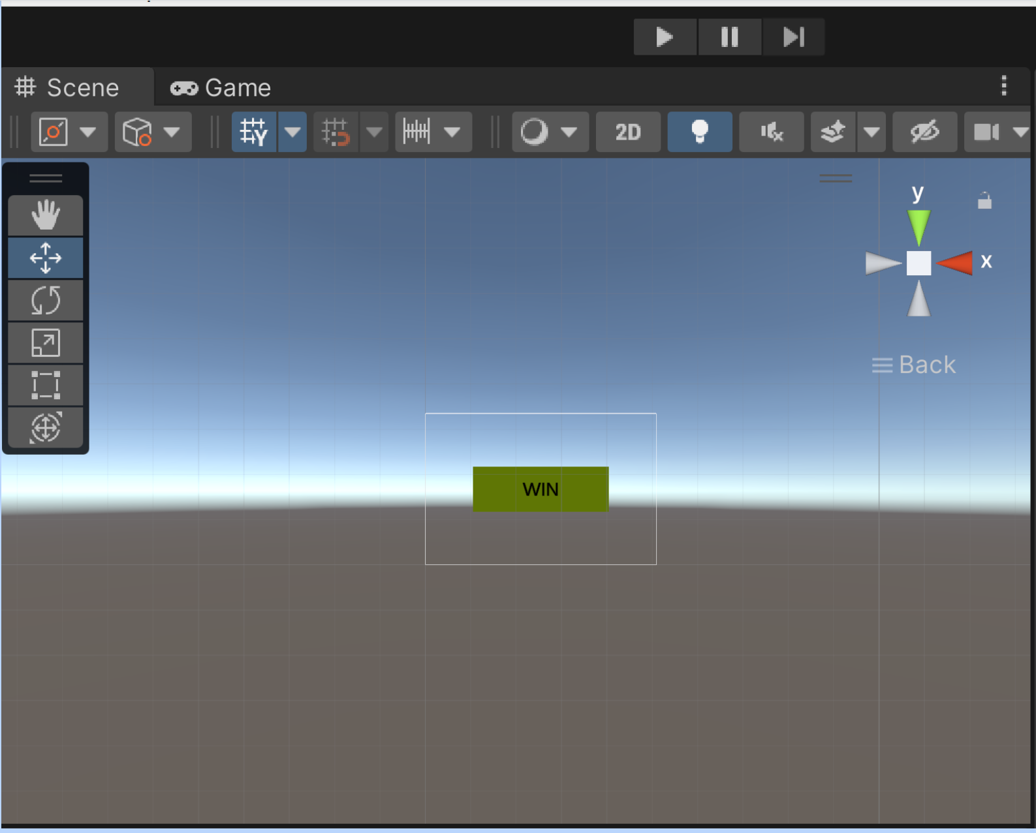

# Appendix

[1] Unknown. “Microsoft Ignite.” Learn Microsoft. URL (accessed October 2, 2022). [Prepare a new HoloLens | Microsoft Learn](https://learn.microsoft.com/en-us/hololens/hololens1-setup)